Learn to Program in JavaScript: Beginner to Pro

Introduction to JS

Intro

- JS is lightweight programming language developed by Brendan Eich.

- JS was first coined as LiveScript but when Netscape partnered with Sun microsystems, they changed it to JavaScript.

- JS makes the website responsive and usable since it is a programming language

- ECMA (European Computer Manufacturers Association) standardize JS.

- JS can be linked to HTML or used with in a HTML file. <script> tag is used in HTML to put JS snippets.

- REPL is a style that browser consoles use, and its full form is Read Evaluate Print Loop. Basically, it loops - reads, evaluate and prints, so we can simultaneously give inputs and checks in the browser.

Data Types

- var is a variable declaration keyword. Unlike other programming languages JS variables doesn’t need to declare its type so it is called DYNAMICALLY TYPED whereas other programming languages like C, C++ and JAVA are statically typed. Ex: var messages = “Hello”; . The browser interpreter/compiler dynamically sets the type of variable when we assign value if not it simply takes undefined.

- JS has categorized its data types into 3 as follows,

— Primitive (Numbers, String, Boolean)

— Object (Apart from primitive types all other types are considered objects even functions are considered as objects)

— Null (is a special type of object in JS that represents “no-objects”)

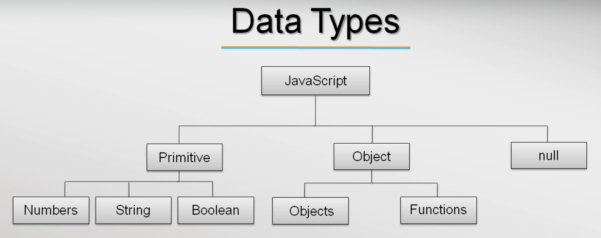

- Undefined is a type of undefined and represent absence of value.

- The below is a REPL concept the chrome console first reads from me and evaluates it and prints it as undefined and gain the console terminates.

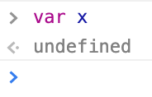

Flavor of JS

- JS is a scripting language (set of statements which will be interpreted)

- It also supports functional (JS functions are first class citizens that is they are given the first priority, functions is treated as data or var may holds functions) and OOP (not class based but prototype) languages

- It is dynamically typed. Whereas C, Java are statically typed.

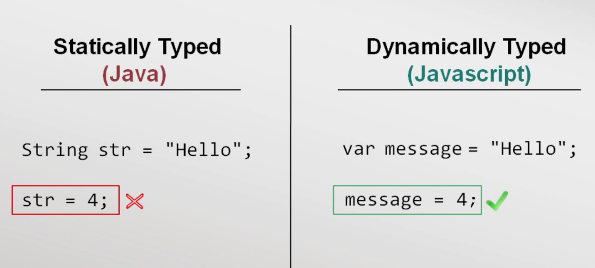

Ex:

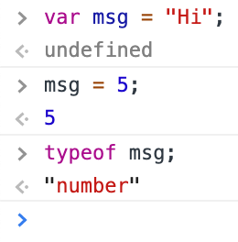

String datatype

- Each character of string uses 16 bits of storage. It uses UTF-16 by default.

- We can use either “ ” or ‘ ’ for strings.

- var msg “Hello world”, where Hello world is literally a string, so it is called string literals.

- JS has no inbuilt character data set they only have strings.

- To use “ ” or ‘ ’ in a variable we can use escape sequence (\).

Ex:

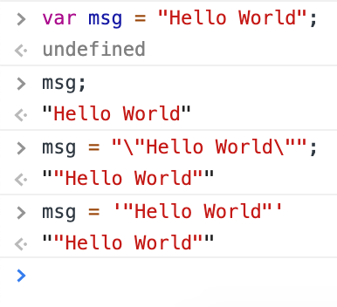

Number datatype

- JS has no type (int, float) for numbers except number is a datatype and it is stored as 64-bit floating-point number.

Boolean datatype

- Falsy values in JS are undefined, null, 0, NaN (Not a Number) and “” (Empty string).

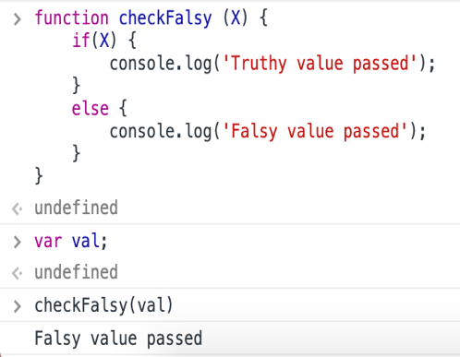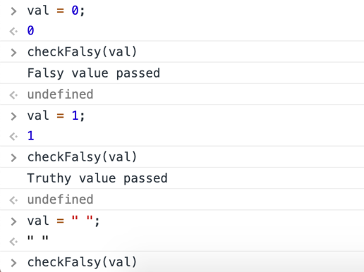

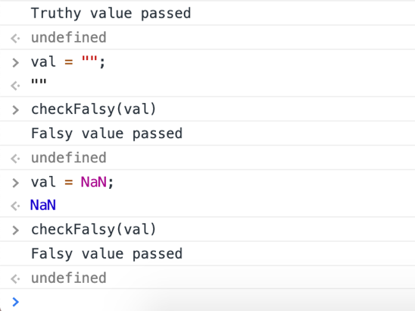

Comments

- //single line comment

- /* multi line comment */

Operators

- Mathematical operators: +, -, *, / and %.

- Conditional operators: <, > <= and >=. Ex: “aa” < “ab” 🡪prints true

- Equality: == and Inequality: != Ex: “2” == 2 🡪prints true, *the reason is to throw minimum errors. “2” === 2 -->prints false, this === checks type of the variable or value.

- String operators: typeof and instanceof.

Statement and Expressions

- var x = 5; is a statement and is evaluated as undefined in a browser console because it is not returning any value so it is undefined.

- x = 5; is an expression but is evaluated as 5 that is console prints 5 since we assign variable to a value which is not undefined.

/*The first is a statement, while the second is an expression. While not quite the same, it is similar to C's rules:

// A statement that has no value.

int x = 5;

// An expression...

x = 10;

// ...that can be passed around.

printf("%d\n", x = 15);*/

* literals mean string literals and constant means a number.

Control flow statements (if-else, nested if-else, switch)

- if works with range of values.

- switch works with discrete values.

It’s better to use if than switch because switch consecutively executes the cases after the desired expression. To avoid that break; should be used for each case.

- while executes code block when the expression is true.

- for loop is sugar syntax of while loop. JS has another version of for loop which is called for-in loop.

- break and continue are keywords which we can use inside a looping statement. Just fir our convenience.

Ex: break statement

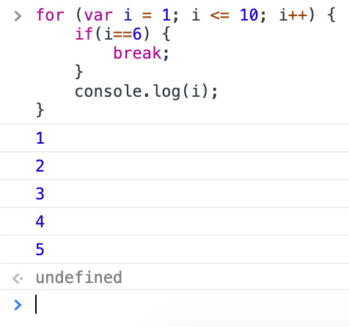

Ex: continue statement

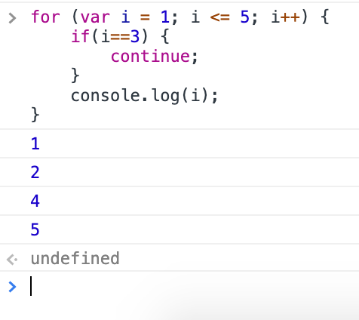

Functions

- JS is a functional programming language so JS treats all functions as first class citizens.

- Functions are treated as data or objects.

- We can even pass a function as arguments to a function.

- function keyword declares a function.

- function parameters don’t have type information same like var.

- Functions basically returns something, even JS functions returns same like C++ or Java. But in C++ or Java when a function has nothing to return it returns void whereas JS returns undefined.

Ex: Function returns

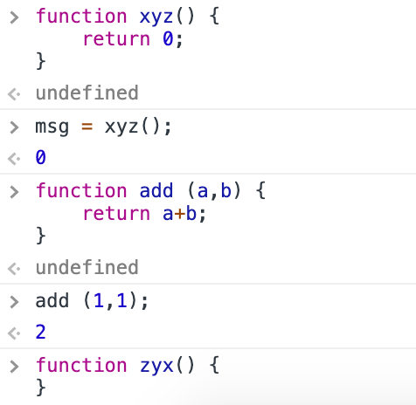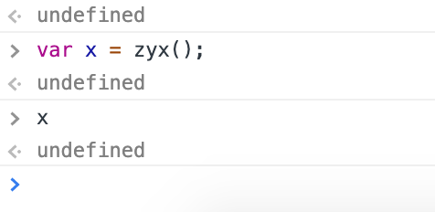

Block Scope

- A variable defined or declared in a class or function or in a control flow statement then that variable can only be accessed with in the block. This is called block scope.

Block scope

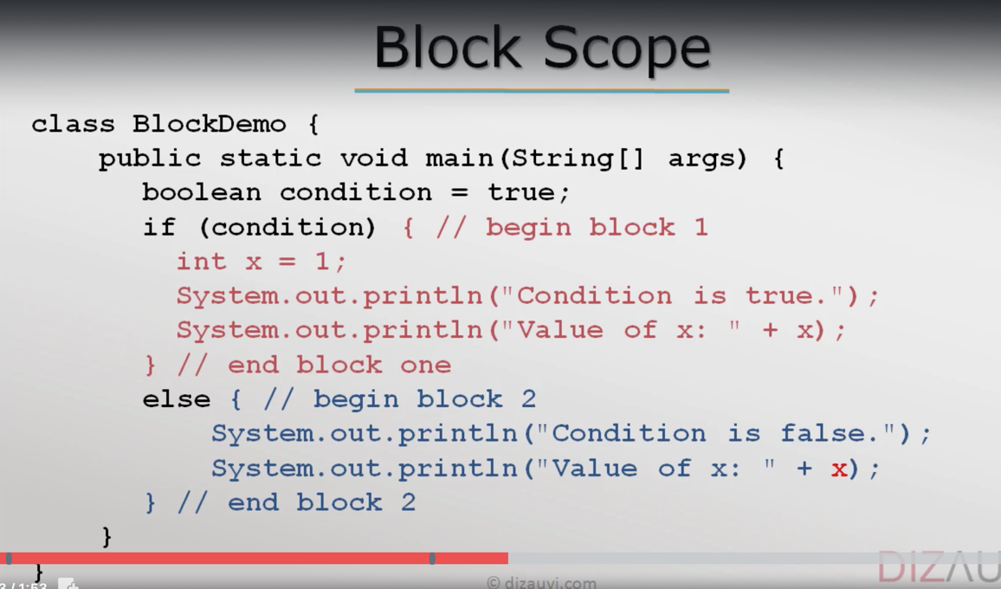

- In JS we have function scope in addition to block scope.

Function scope

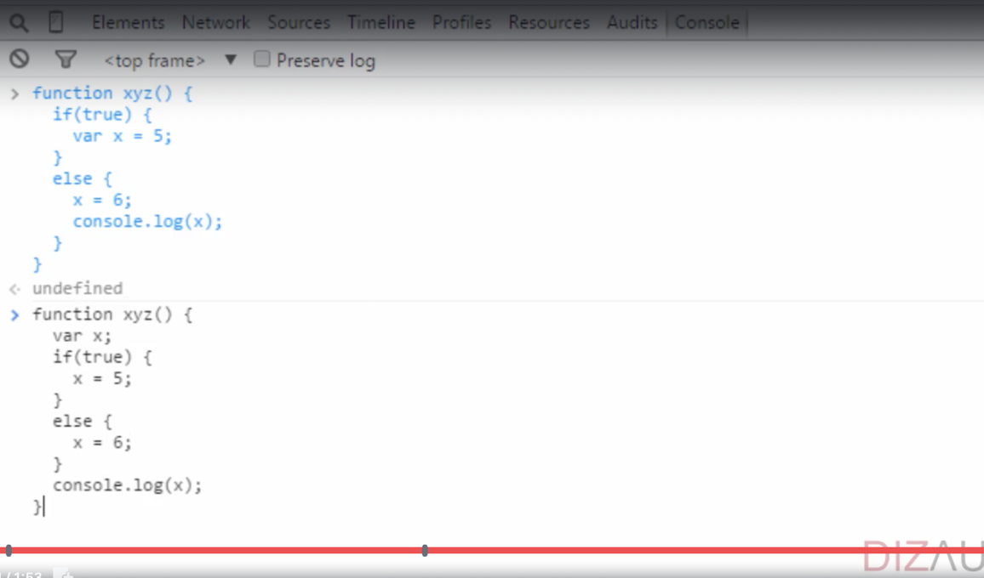

Type Conversion

*The basic difference between type conversion and type casting, i.e. type conversion is made “automatically” by compiler whereas, type casting is to be “explicitly done” by the programmer. The two terms “type casting” and “type conversion” occur when there is a need to convert one data type to another.

*Also, operators do more function apart from their normal nature. like the + operator can add to numbers but also appends two strings.

- JS also use this concept of type conversion, to throw minimum error.

Ex: Below the * and + are treated differently. Though “2” & “3” are strings they are considered numbers when we use * but when we use + the interpreter appends because + is defined to do the appending operation.

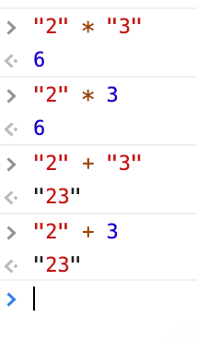

JS in a web page

Always put JS codes in a single place instead of using script tags throughout the HTML. It can be done in that way but it is a bad practise. The below html code has lots of script tags it can be written there but it’s better to put code in a single file and link.

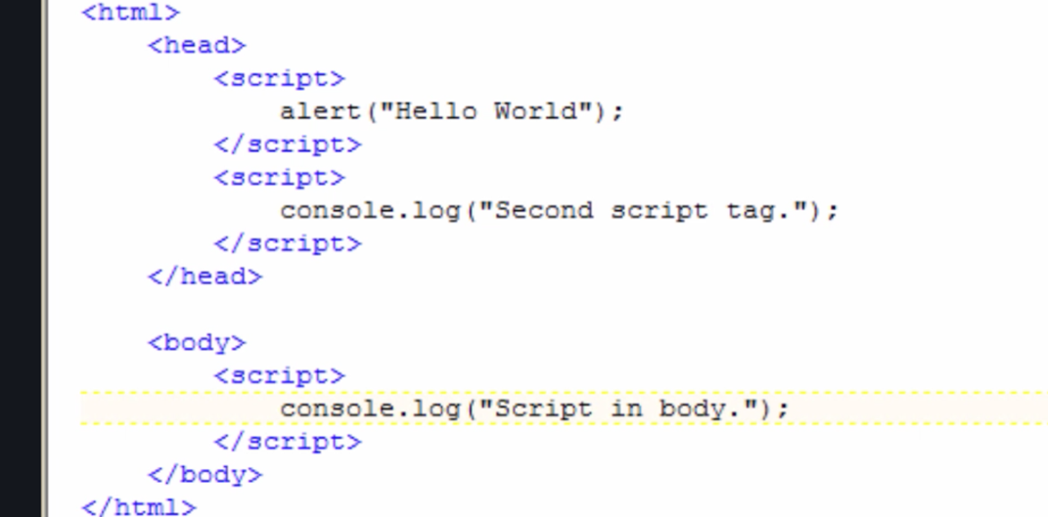

The above picture also shows that the browser will start to execute from head to tail since the html file has multiple script tags. So, the first script tag is executed later the other.

External JS or linking to a HTML

- Using external libraries like JQuery, angular JS etc

- Code can be better organized and reused

- Intellectual property (not easily access to any one)

- Cached by browser (download JS from the server and stores in system)

*Try to use relative path in src attribute of html tag.

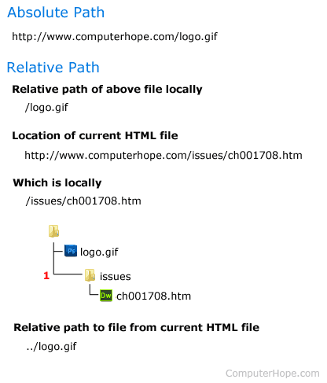

*Don’t use the http or https literals in src since there might arise a problem when the html code communicates with the source. If in case the link has http convention but the source as https then warnings or errors may populate. So, it’s better uses the below,



Ex:

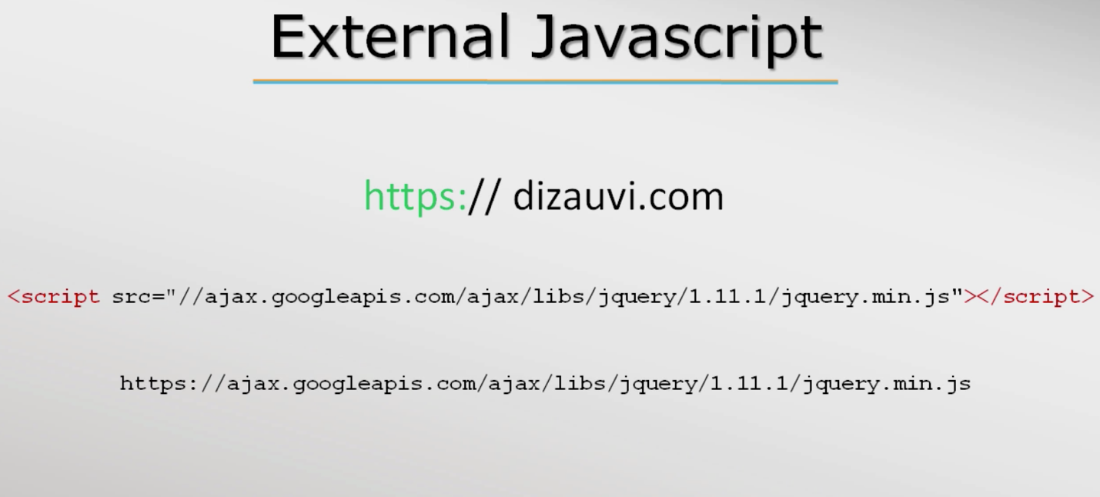

Objects & Array

Objects

- JS provides general object data types basically unordered collection of properties

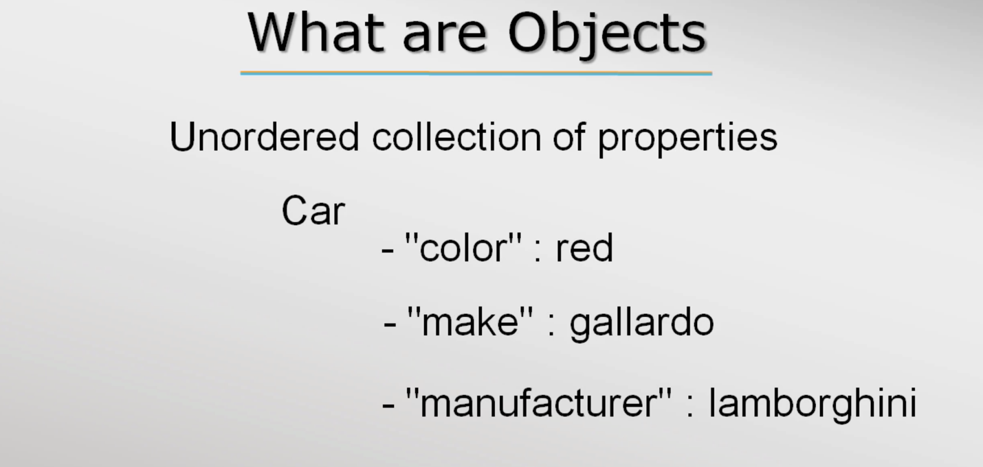

- “color” 🡪 property name and they must be a string but it is not necessary to put in “ “

- red is a value for the property “color”

- A property can hold anything, it could be a primitive value or even objects

*JSON – Java Script Object Notation

Ex:

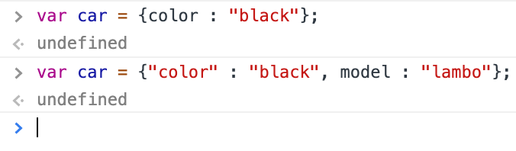

The object data structure above is called dictionary in python

Empty objects

>var car = {}; //is a object without any properties

<undefined

>car;

<Object {}

- new is a keyword to initialize an empty object i.e without properties. Later properties can be added using (.)dot operator

>var car = new Object(); // var car is initialized with new object

<undefined

>car;// car is empty object

<Object {}

>car.color = “black”; // adding properties to the object

<“red”

>car;

<car = {color : “black”}

*Difference between instantiation and initialization: Instantiation refers to the allocation of memory to create an instance of a class whereas initialization refers to naming that instance by assigning the variable name to that instance.

- In JS we don’t need not use classes the way we use in C#, Java

- JS supports OOP but not class based, it is prototype based*

- Another way to create object is to use create() method

Ex:

> var car = Object.create(null); // create takes argument so pass null to create a empty object

<undefined

>car;

<{}

Object properties

- Properties can be read and written to an object in some ways one such way is using (.)dot operator and the other way is using associative array.

- Associative array ex,

>var book = new Object();

<undefined

> book[“title”] = “Cracking coding interview”; //Write

< “Cracking coding interview”

>console.log(book[“title”]); //Read

- to delete a property just use delete keyword

Ex:

>delete book.title;

<true

>book;

<{}

- to iterate over object properties in JS, for/in loop is used.

Syntax: for/in loop

for (var x in book) { }

Ex: for/in loop

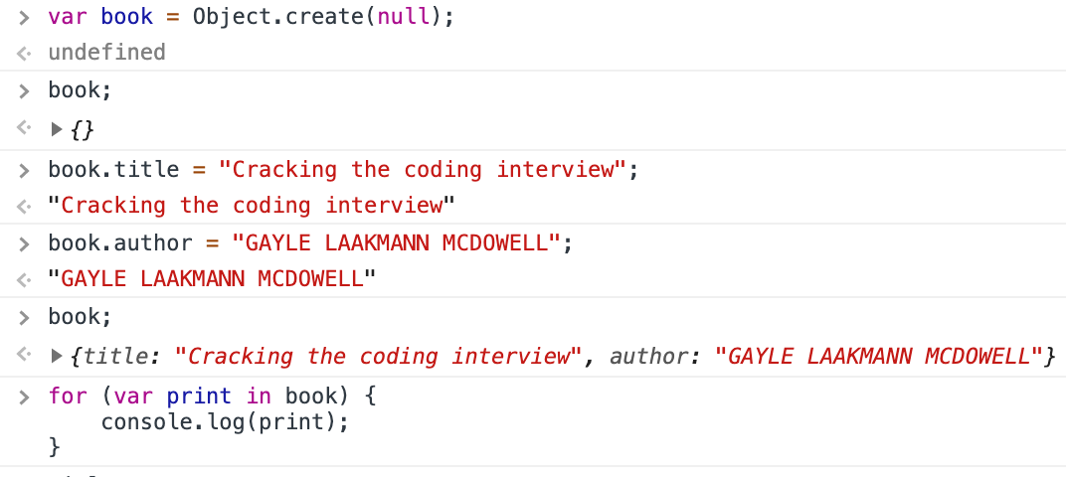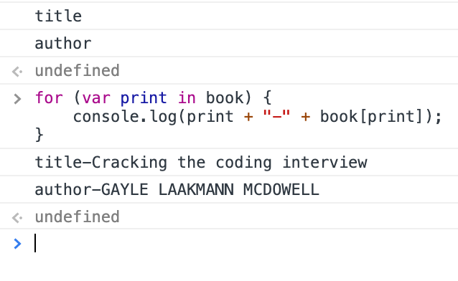

- Normal empty object has additional properties which comes from object prototype.

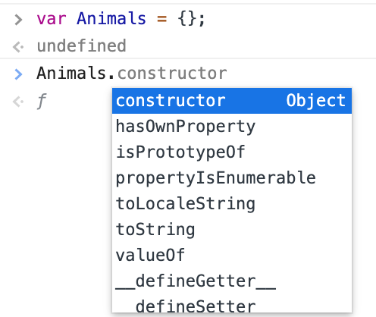

*Difference between class and prototype : Prototypes vs. Classes. The most important difference between class- and prototype-based inheritance is that a class defines a type which can be instantiated at runtime, whereas a prototype is itself an object instance. ... A class constructor creates an instance of the class.

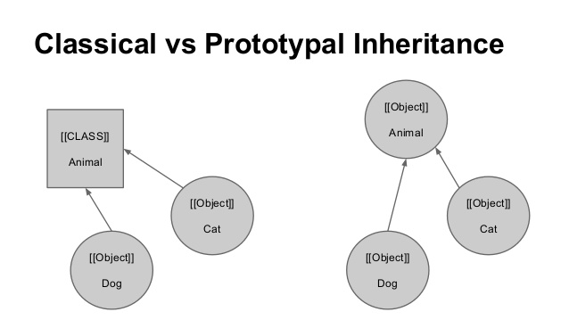

JSON – Java Script Object Notation

- It is a very popular form of representing data as string.

- JSON is a data format used to send data in strings between client and server.

- There are other data format like XML but JSON is primitively used since the data format is readable.

- JSON data is represented similar to Objects representation in JS but both are different. Where Objects accepts ‘’ while JSON doesn’t accept single quotes ‘’.

*JSONLint is an open source project which allows you to validate your JSON data. Since when you are working with any programming language and JSON, if your JSON data is not properly formatted, it can cause error, it is better to validate your JSON data beforehand.

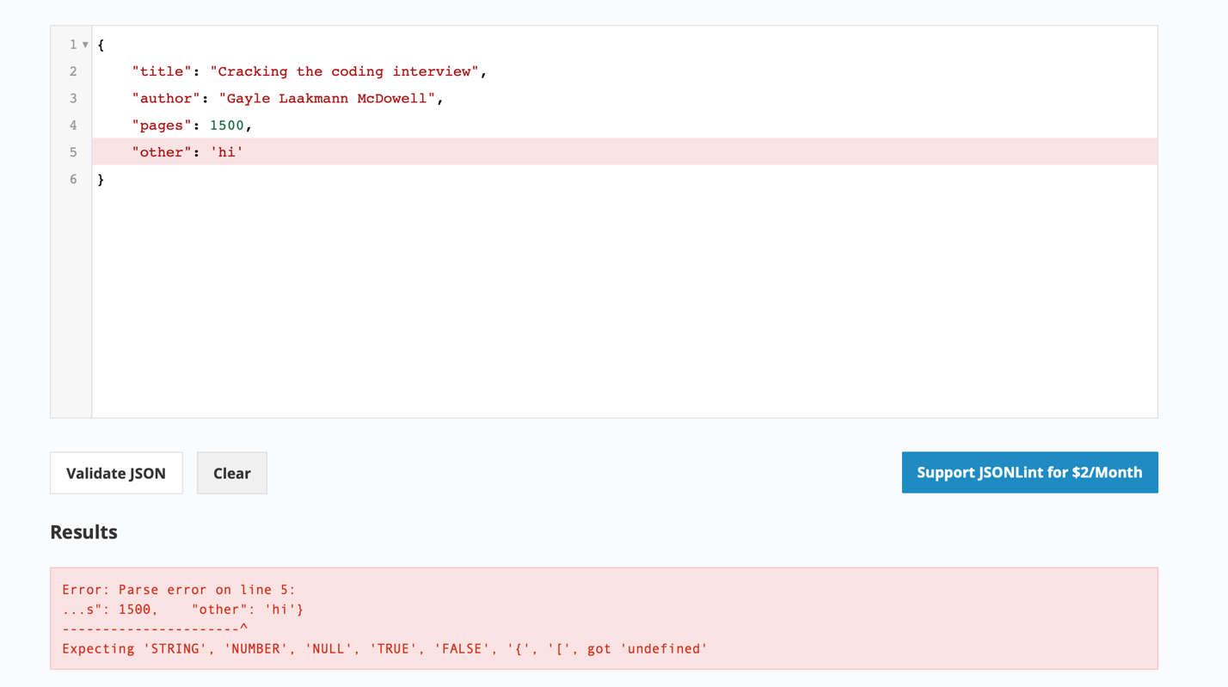

Converting var book_as_string – string literals which is in JSON format to Objects using JSON.pasre() method

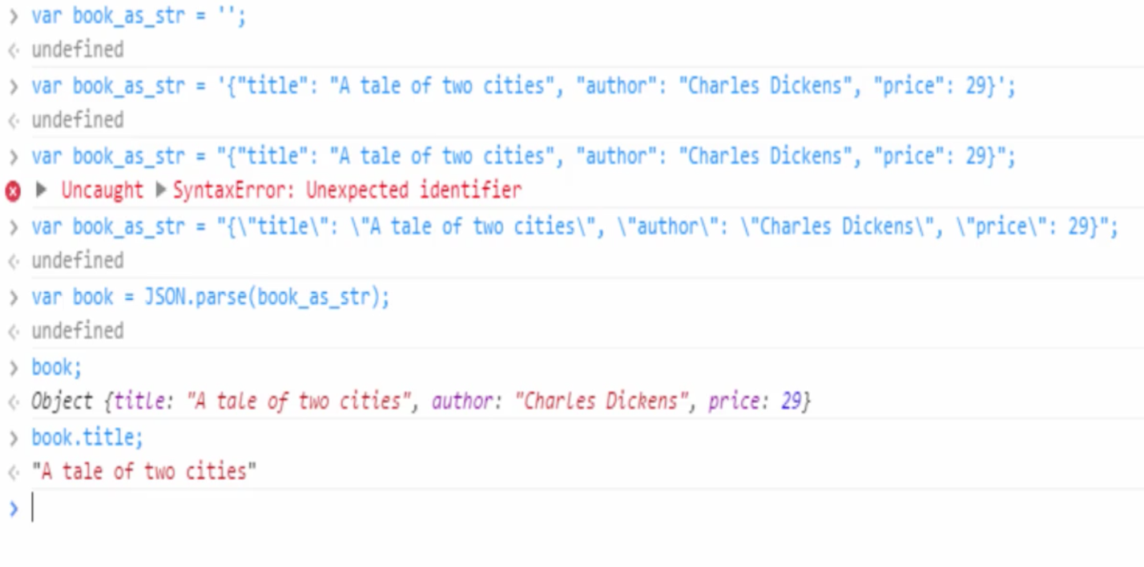

*

- XML are really a big deal to parse data in JS. And this is why exactly JSON’s are prominent.

- JS objects can also be converted to JSON

* The default conversion from an object to string is "[object Object]"

- What is the output of the following code snippet?

>({title : "The Three Musketeers", author: "Alexandre Dumas", price: "$49"}).toString()

<[object Object]

Global Object

- Like other programming languages JS also links functions but it happens quite different here.

- JS has no linker but has globalThis object, which ties everything together.

- In the browser environment globalThis is the window object, so when the new pages load up JS interpreter starts and creates a new window and put all properties.

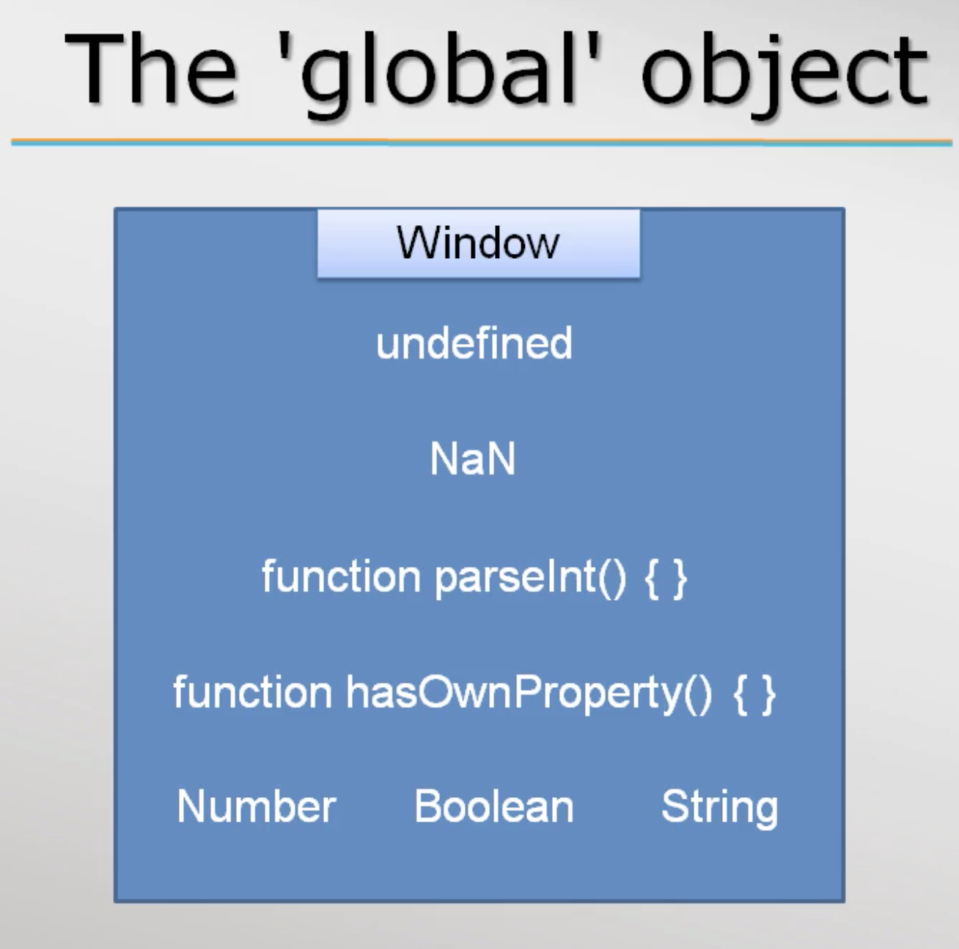

- JS interpreter always has a globalThis object but in case of a browser globalThis is called Window.

Both are same 🡪

>global === window

<true

- the variable, functions and objects which is created will become part of Window object.

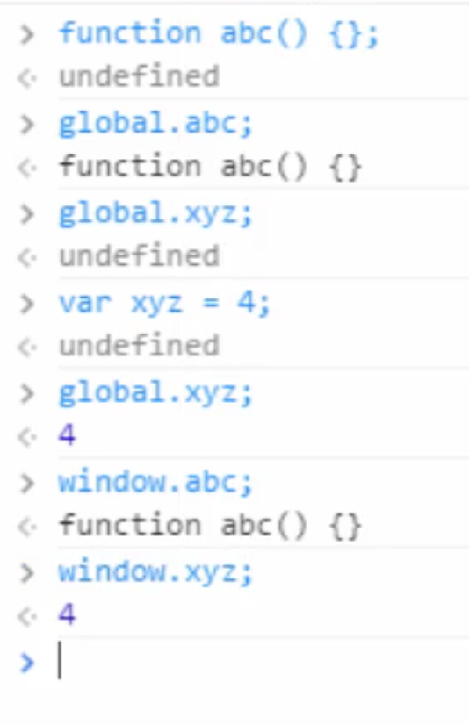

Arrays in JS

General definition of an array: Array is basically a data structure or container object that holds a fixed number of items of specific types. Memory layout of an array is contiguous

But in JS Arrays don’t follow their general nature.

- They can be initialized with zero element.

- items can be added to the array later. That is it grows dynamically.

- obviously they don’t have a data type. Hence we can store any type of element.

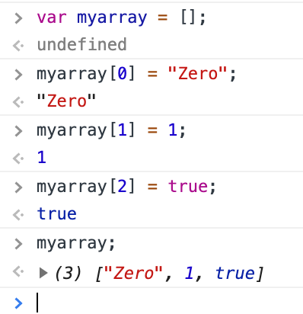

Sparse(scattered) Array

In JS we can load values to any index without error and warnings.

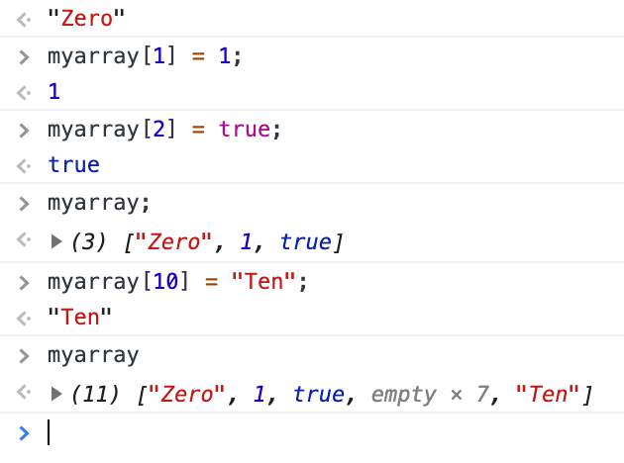

In other programming languages array elements should be adjacent to each other. But JS overrules the traditional rule.

Array as objects

- The reason why arrays are so convenient in JS is because they don’t have any underlying data structure. They use objects has their data structure.

- Arrays work like this🡪 Array indices are converted to strings and these strings will hold values. Exactly like properties in object, where properties are strings. can hold. Hence JS just makes up array but in fundamentally it is an object.

The below code snippet shows array as objects,

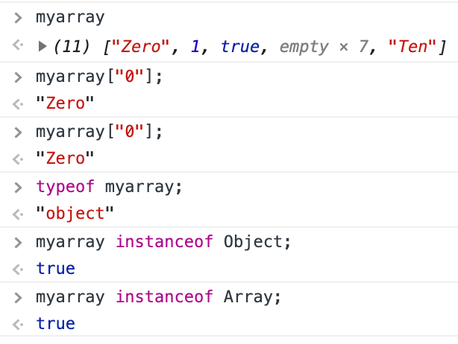

Array is a function but remember a function can also be an Object in JS.

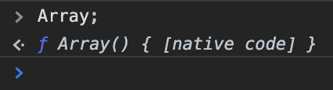

Here the myarray takes a string as indices but still add the values to it.

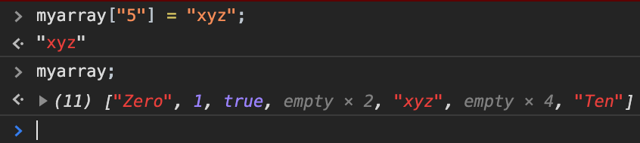

Length of an array

- As previously mentioned, array is an object in JS. So it has predefined properties. Length is one such property of array object. Length property can be accessed as show below,

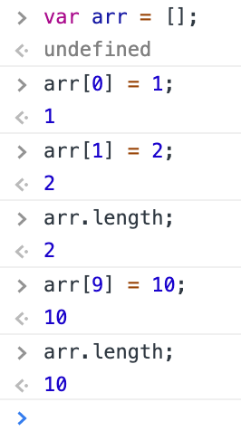

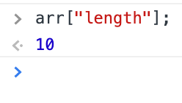

- Since length is a property, we can also use the index notation to print length of the array.

- When iterating an array of 10 elements it shows undefined for 7 which in between the index of 2 and 8. Because as in the previous screenshot it is shown that only 3 indices [0,1 & 9] of array were assigned rest were left empty. So the console throws undefined for the 7 elements and pints the value for rest.

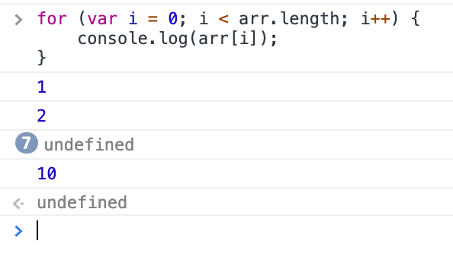

- Since length is a property, we can also set value to it. Like shown below, if we set less value to length property though it’s length is beyond the assigning value. It will still accept the value and will truncates.

The length property can be dynamically change when we assign new value to different indices.

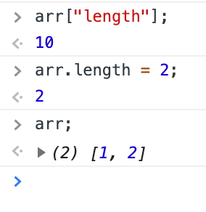

Iterating over an array

For loop can be used to iterate over an array. What if we want to iterate only the valid elements. In the screenshot below for loop iterates all elements including the undefined, which are not assigned.



The below condition can be used to avoid undefined,

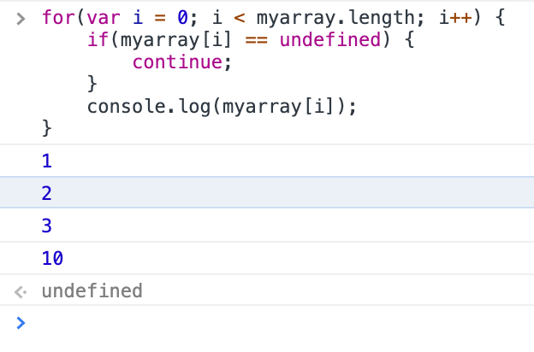

Or we can also use for/in loop, that access each property of an object. For/in loop leaves out undefined property.

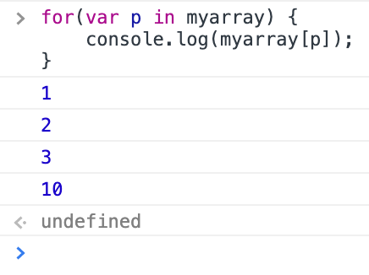

- but for/in loop is not recommended to use because JS may add property to array object and it might print. So the best way is to use “hasOwnProperty” property like below,

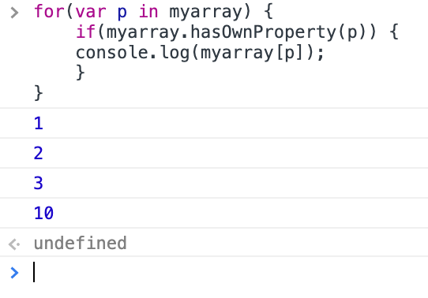

Deleting elements of an array

- Simply use delete key word and mention the index of the element to delete. Array length will not be affected, JS just assigns the deleted element to undefined.

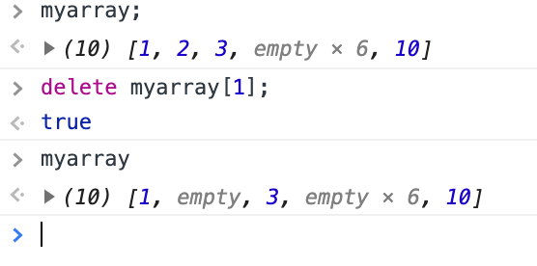

- if we want to shrink the length of the array element when deleting an element, splice method should be used

Methods in an array

- concat

- join

- push and pop

- splice

- slice

- sort are some basic methods in array object.

- concat(): used to join 2 or more array into one.

Ex:

>var a = [1,2,3];

<undefined

> var b = [4,5,6];

<undefined

>var c = a.contact(b); //concat method takes array as argument

<undefined

>c;

<(6) [1,2,3,4,5,6]

>var d = a.concat(b,c);

<undefined

>d;

<(12) [1,2,3,4,5,6,1,2,3,4,5,6]

- join(): gives the string representation of an array with a separator. The default separator is “,” but we can give any thing we want.

Ex:

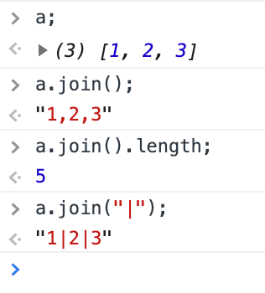

- push(): add new element at the end of the array and returns length of the array. Similar to push unshift() is a method that add elements at the start of the array.

Ex:

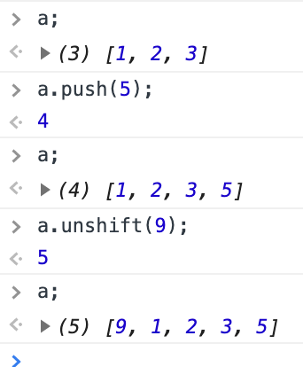

- pop(): is used to remove the last item and returns the element of removed. Shift() is used to remove the first element of the array and returns the item removed.

Ex:

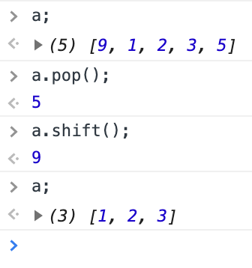

- slice(): slice returns a new array object without affecting the old array. And it takes at most of 2 arguments, the first one is the start index and second one is the end index.

Ex:

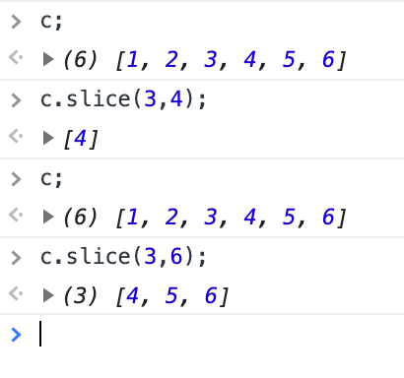

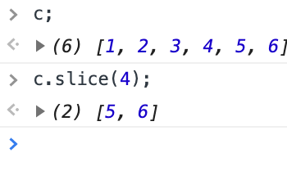

- splice(): splice returns a new array object of spliced element from the old array and also splices up the old array. It take 2 arguments like slice. The first arguments denotes where the index starts while the second shows the number of elements to be removed after the start index.

Ex:

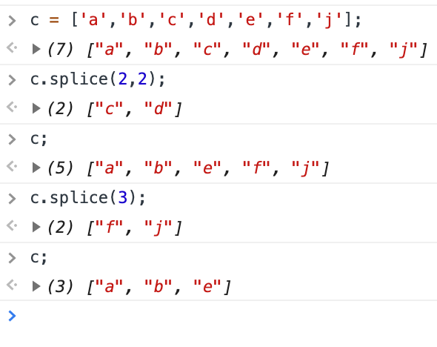

After the 2nd argument it can still take arguments, but they are used to replace the element of old array.

Ex:

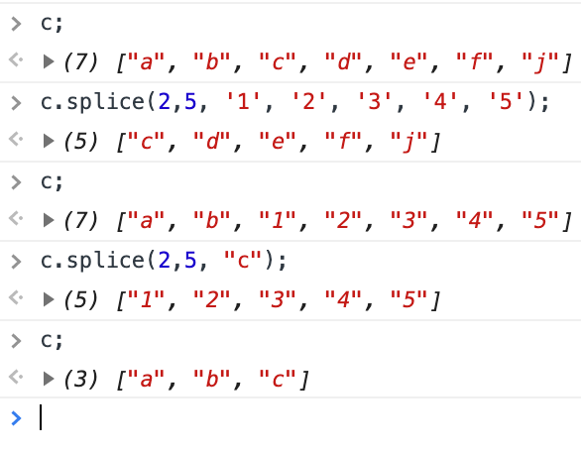

- sort(): will sort the array in ascending alphabet order or lexica graphical or dictionary order.

Ex: this is how the array sorts,

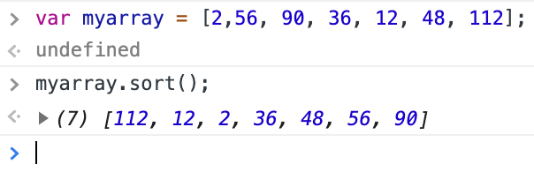

To sort array properly we should use a function and the below is the algorithm of the function should work

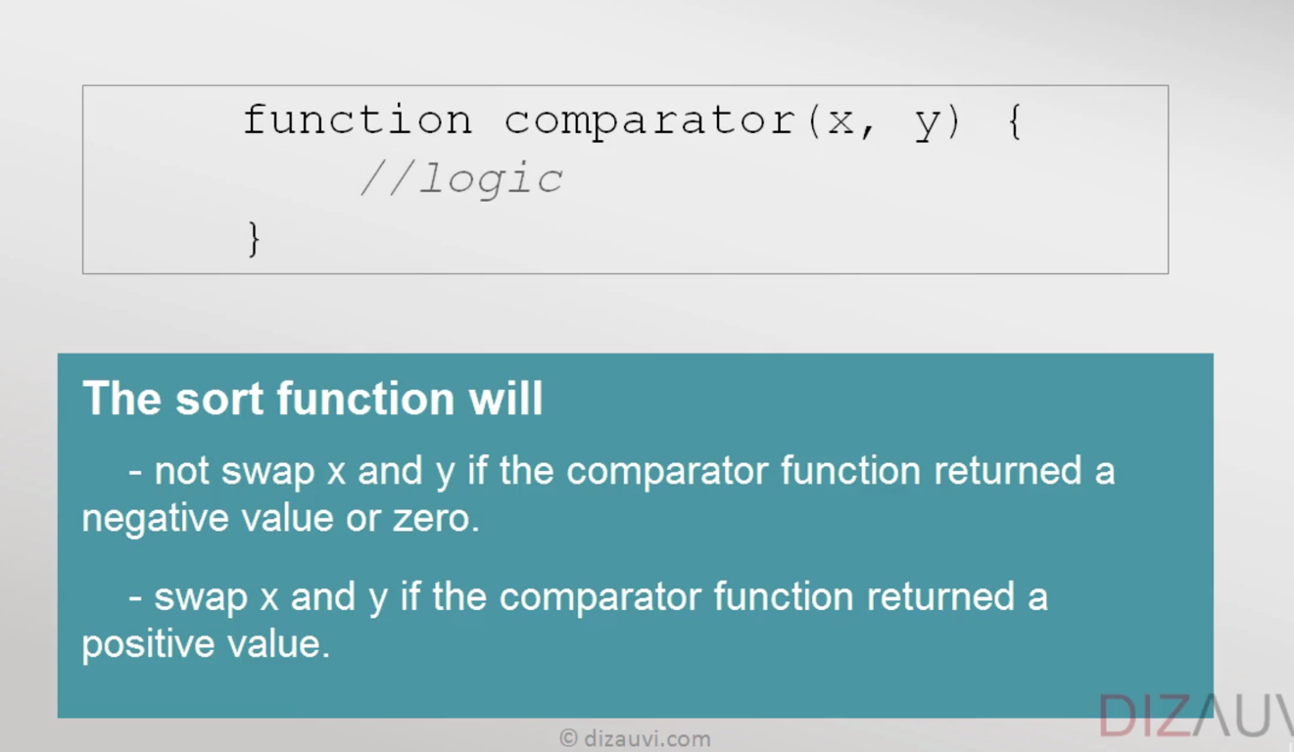

function num_comparator (a,b) {

return (a-b);

}

*no use of parenthesis if a function is not invoked

Ex: the below sorting happened in ascending order

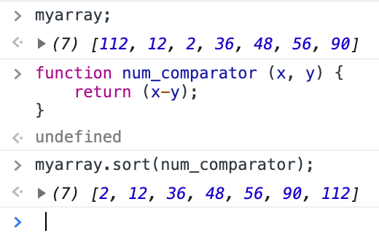

Ex if the sorting to be happened in descending order, just return b-a.

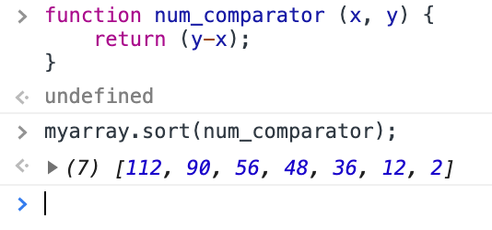

So the sort function only check +,- or 0 of the number returns from the function num_comparator(). And depends on that it sorts.

*idea of passing function as arguments comes under functional programming

Functional programming

Programming Paradigms(patterns)

- Procedural - c

- Object oriented – c++ & java

- Functional - Haskell

And Hybrid (a mixture of above) - JS

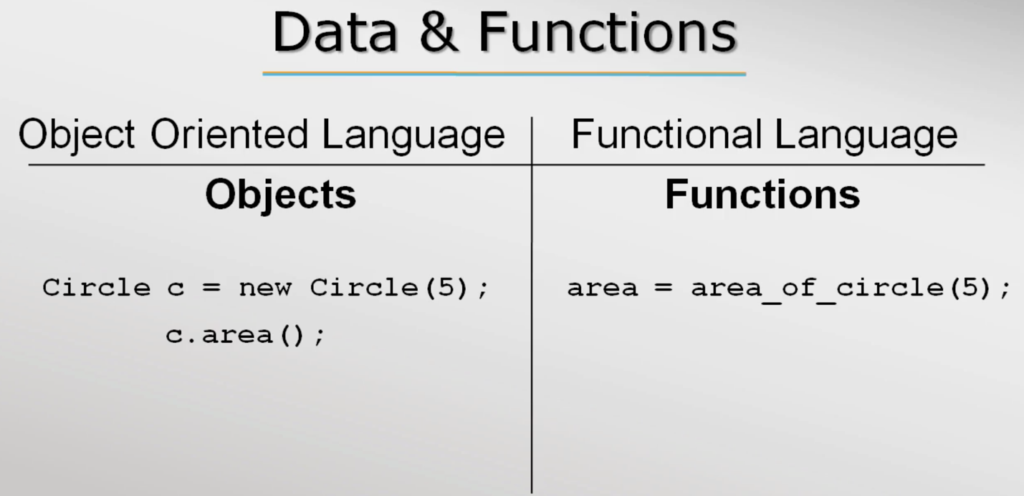

*In the above screenshot the object is created by for the class circle by calling a constructor of the class. This is followed in Java. Whereas, in C++ just object is created without the constructor call. it is implicitly called when the compiler finds the object of the class.

*people always think procedural and functional are same, but they aren’t. In procedural language we can’t store a function in a variable but in functional language we can do that. Since in functional language there is no difference between function and data. Functions are just like objects. 🡺 In JavaScript, functions are first-class objects, because they can have properties and methods just like any other object. What distinguishes them from other objects is that functions can be called. In brief, they are Function objects

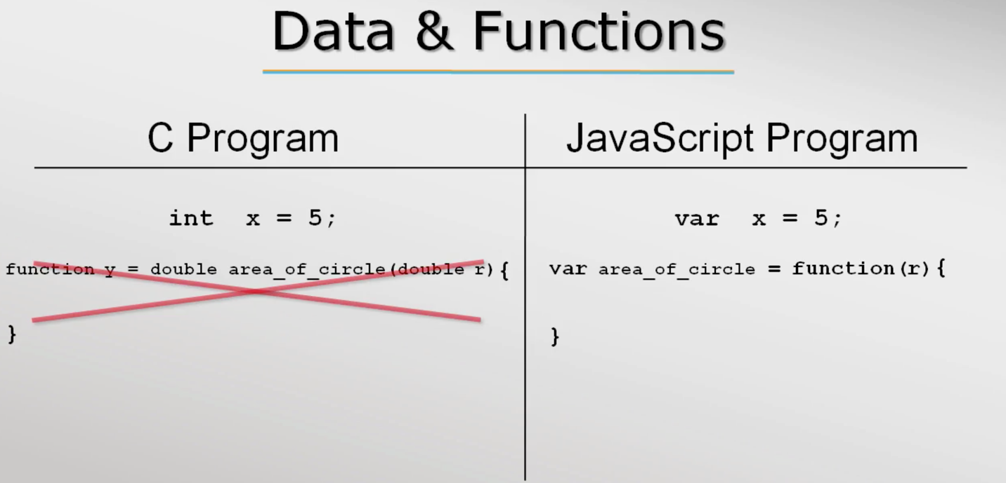

In the example below, you can see that JS treats abc as a variable we can append a value to it and JS takes it as string. But we can also use it as a function and at this time when I append a value it adds.

The forms, function abc() { return 5; } 🡸🡺 var abc = function () { return 5; }

That’s why when I append a value to abc it includes it and gives a string. But if I use the abc as function it will return 5 and appended to the given value. abc() + 6 🡺 11

*So to remember data and function are pretty much treated same

Haskell – data is said to be zero order function and functions are said to be higher order functions 🡪 both are passed as arguments

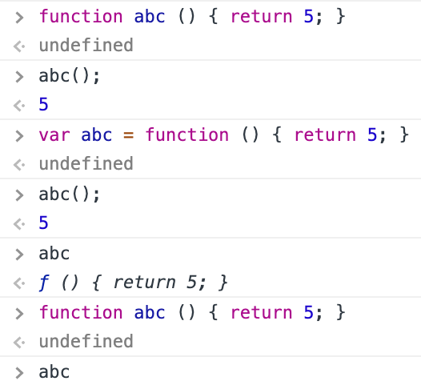

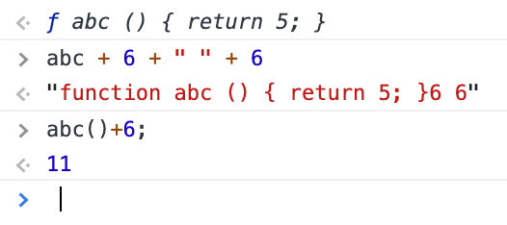

In the above var abc = function () { return 5; } is a anonymous function declaration.

Higher order functions

– functions are passed as arguments since in functional programming functions are considered data

- definition “A function that either takes a function(s) as arguments or return a function” 🡨

🡪 h(x) = f((g(x))

Understanding functions as argument by num_printer example.

- lets create a function that prints 1 to max numbers “num_printer(upto)” typically we will pass a number “upto’as argument to the function print_num(upto) which will print a list of number like this, num_printer(10) 🡪 1 2 3 4 5 6 7 8 9 10.

- what if I need to print odd or even number. mostly what programmers do is write another function which prints odd and even. It’s worth to write another function. In reality it consumes time and effort. So it better to abstract out the changes and pass as argument to the existing function, in this case “num_printer(upto)”, and tell this function to perform required task like print even, print odd or print prime. So this is where functional programming comes to play.

- for the example function we can pass a filter function which will odd out the number.

Ex: function prints max number and takes “upto” as parameter, which will pass number as argument.

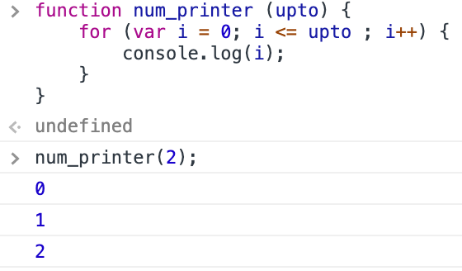

Ex: adding an parameter “filter” to the existing function, where we will pass a function as argument.

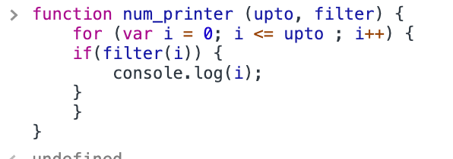

Ex: a separate function that check odd or not and returns boolean is created

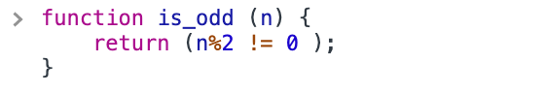

Ex: this is_odd function is passed as argument

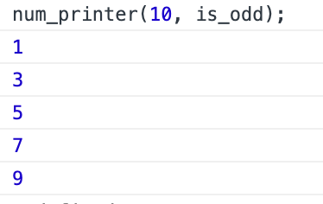

Ex: if I need to print even number means I have to pass another function “is_even” as argument that will return true to the num printer in turn It prints even numbers or if I need to print all number I have to make the if condition true so I need to create a function that returns true.

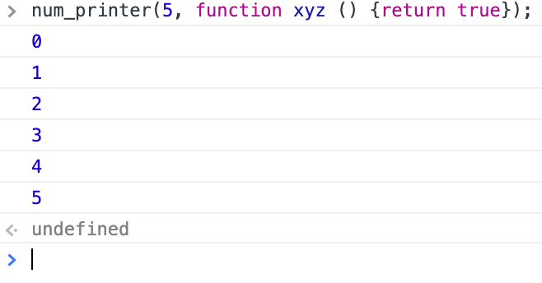

Anonymous function

- Function is JS can be written without function names and they are called anonymous functions

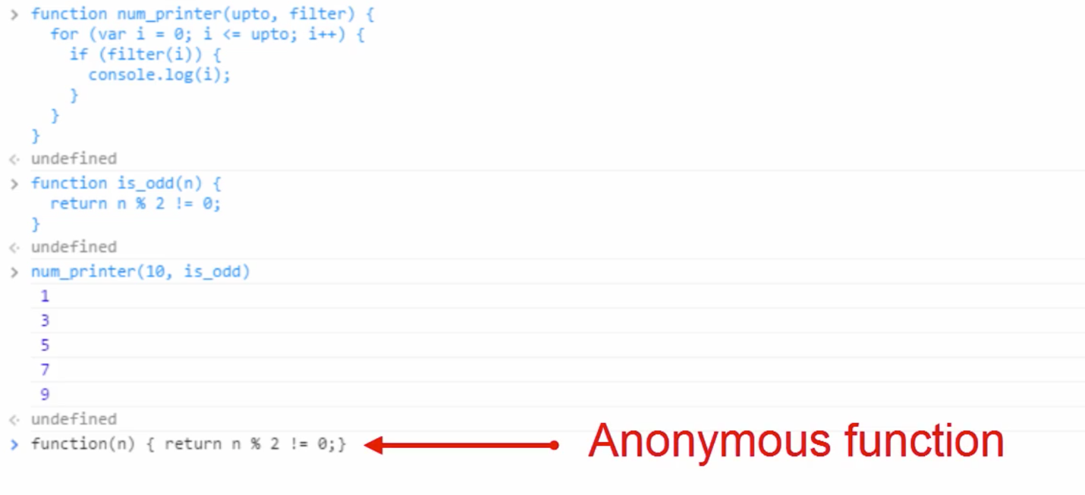

- if we are not giving a name for such function we can’t use it late.

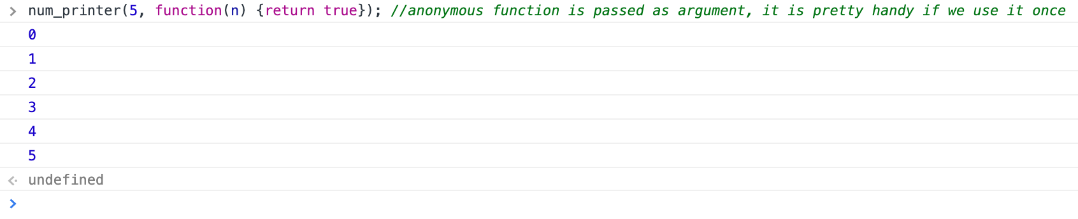

*forEach() is a function that works with array. And it takes function as argument.

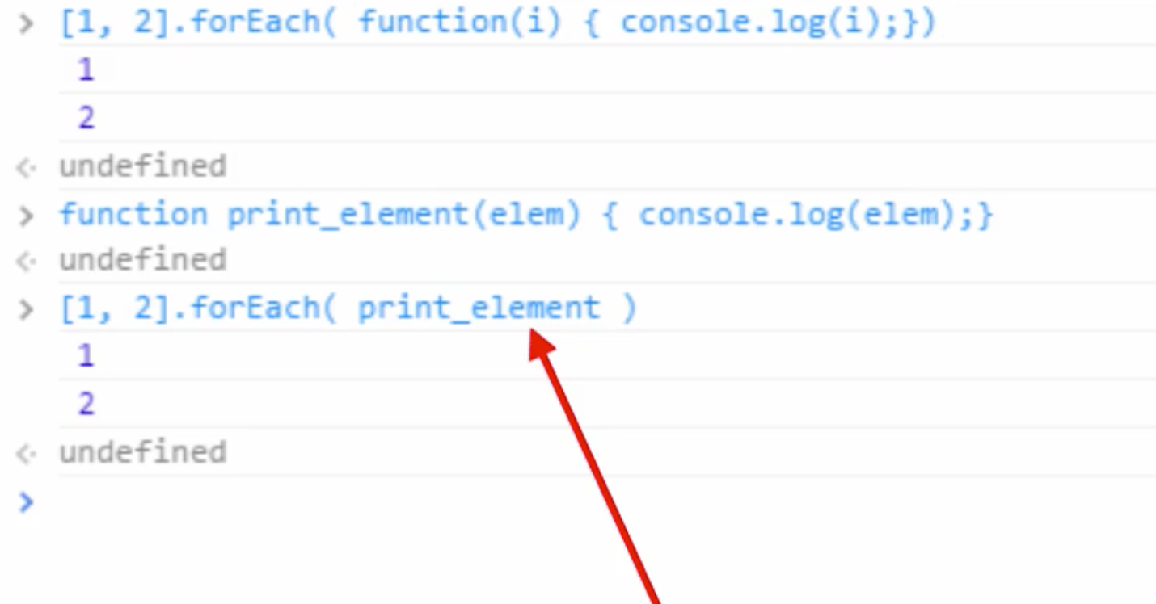

For each function goes to each element of the array and passes the element to this argument, which in turn logged the element.

Nested functions

- function inside another function

- nested function follows functional scope

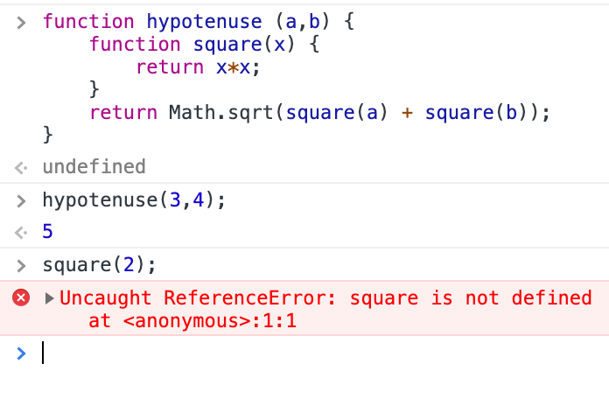

Here I can call hypotenuse function but can’t call square because it is nested. This is applicable to variable.

Closure

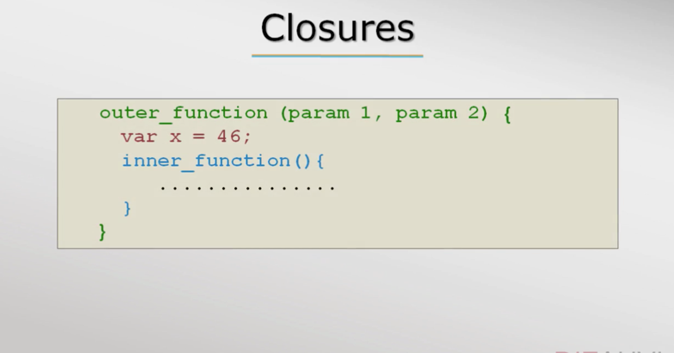

- even when the outer function goes out of scope and the parameters passed to the outer function will be available to the inner function because after all parameters to a function are local variables.

- closure are available inall functional programming language

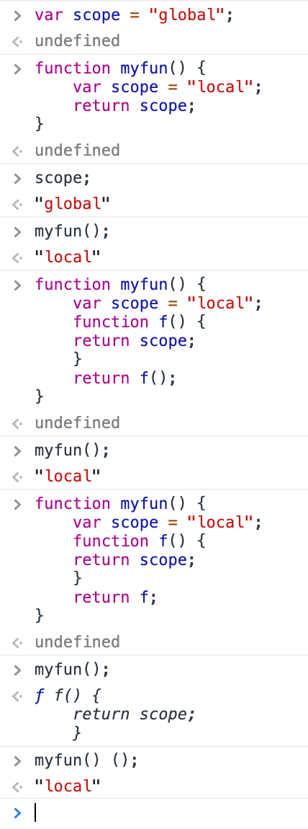

- if no var is loaded inside the function then it checkes global variable

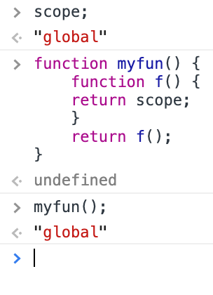

Close example

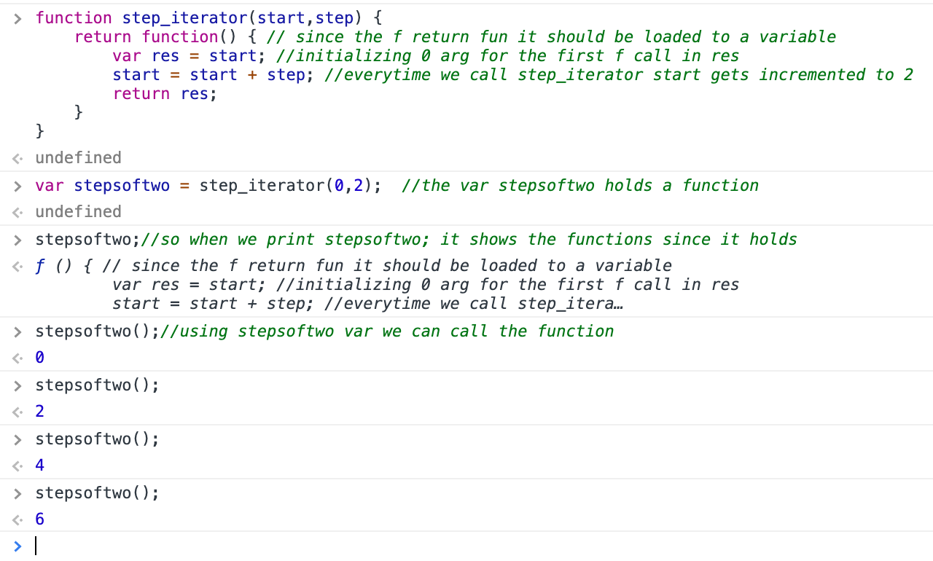

- if we load the same fun in another variable I will start from 0 step

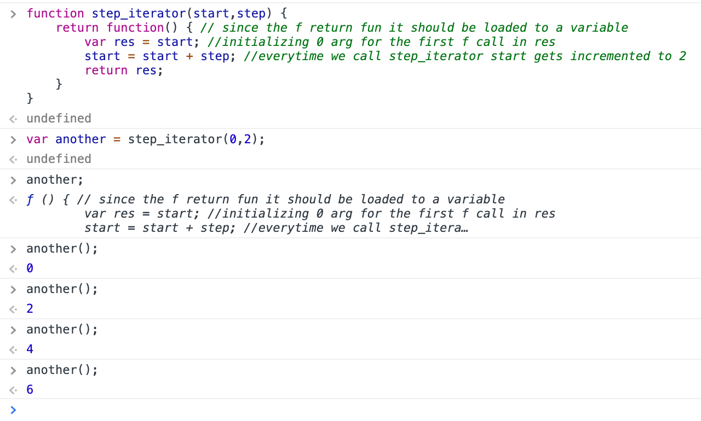

List comprehension

- in many programming languages collection of data or set of data is called as list.

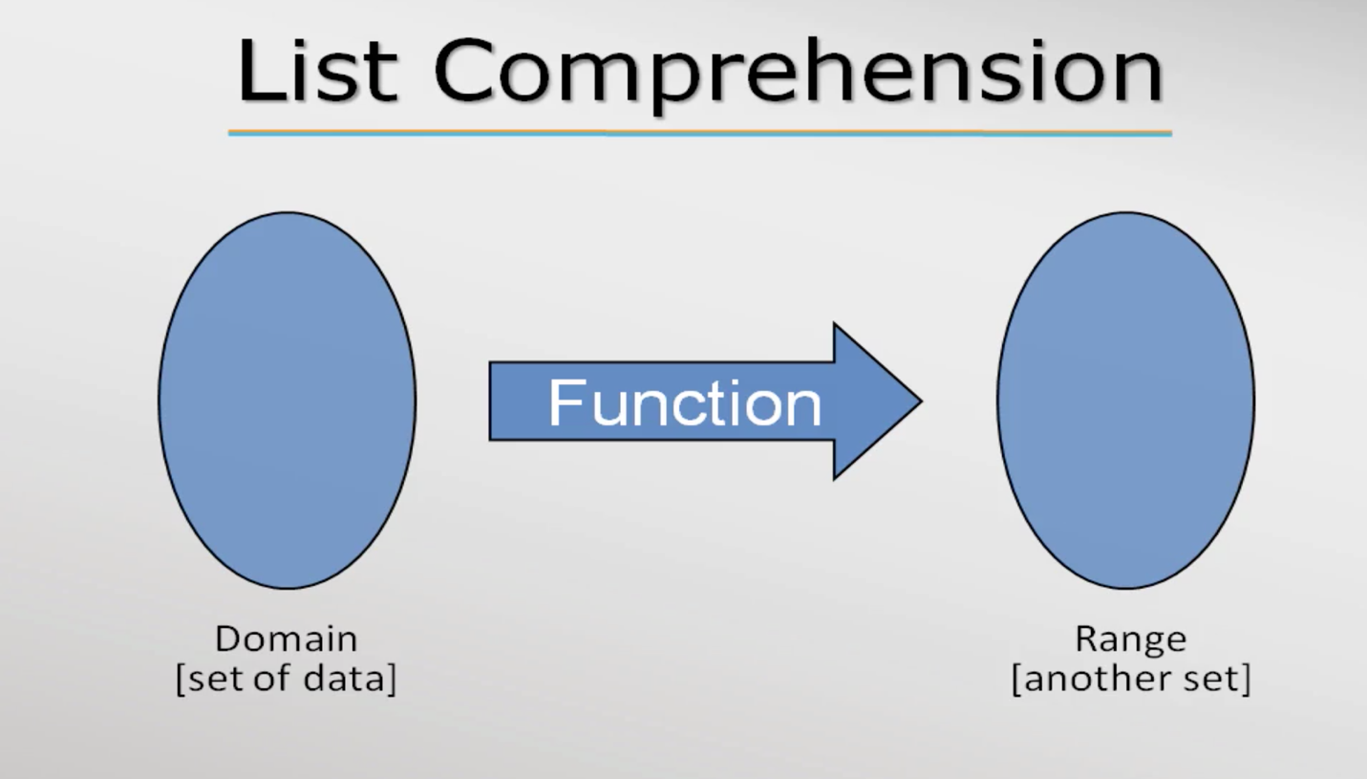

- JS supports 3 list functions,

- filter

- map

- reduce

- List comprehension is basically a feature provided by programming languages to ease the work of developers.

- these list comprehension works on array

- filter function

[2,4,5,6,12,15] 🡺filter🡺 [2,4,6,12]

Filter function take another function as argument it can be anonymous or normal functions



- The anonymous function passed as argument in filter() is called callback function

Callback function syntax:

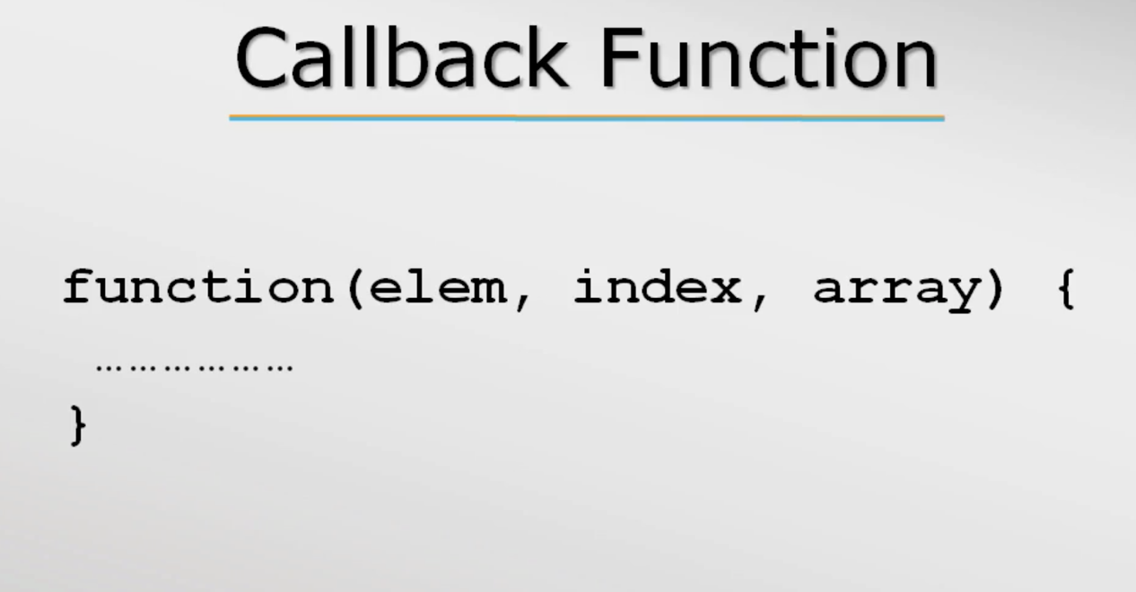

*Callback must return a Boolean value for filter function.

-In call back if only one argument is passed in place of 3 the other 2 are considered as undefined by JS

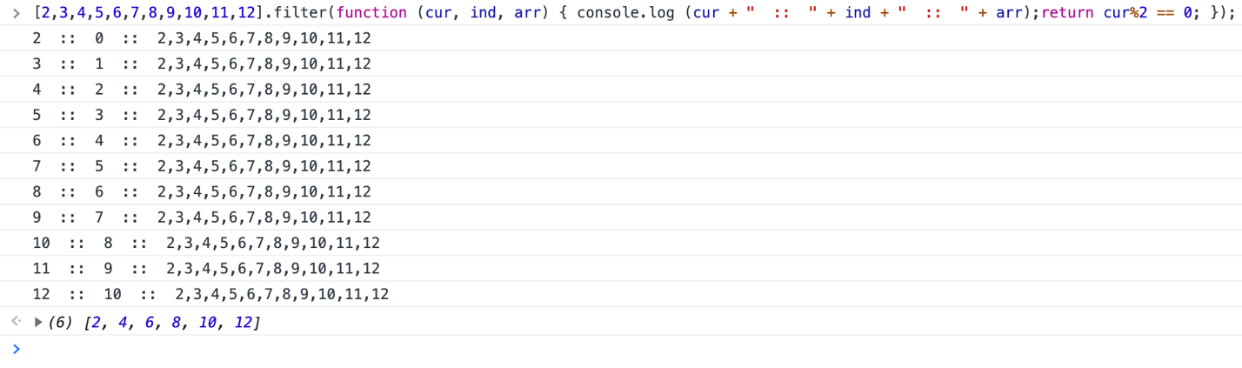

- map function

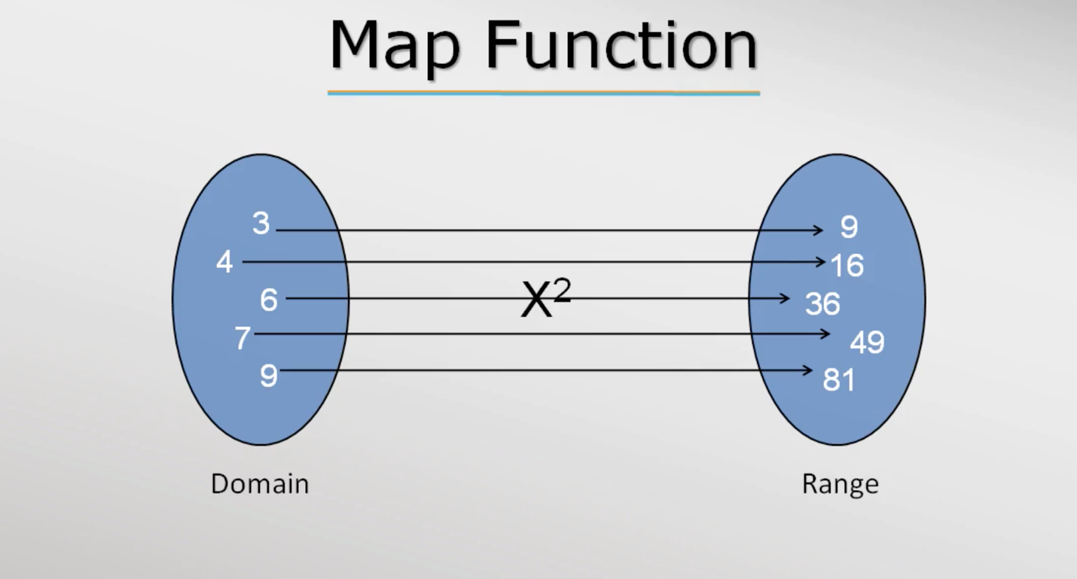

Ex:

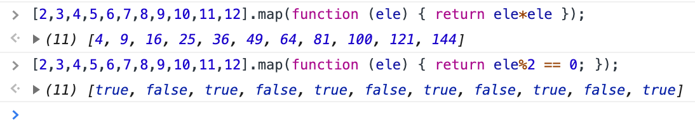

*callback function is similar to filter but it will return a value corresponds to the input.

- reduce function

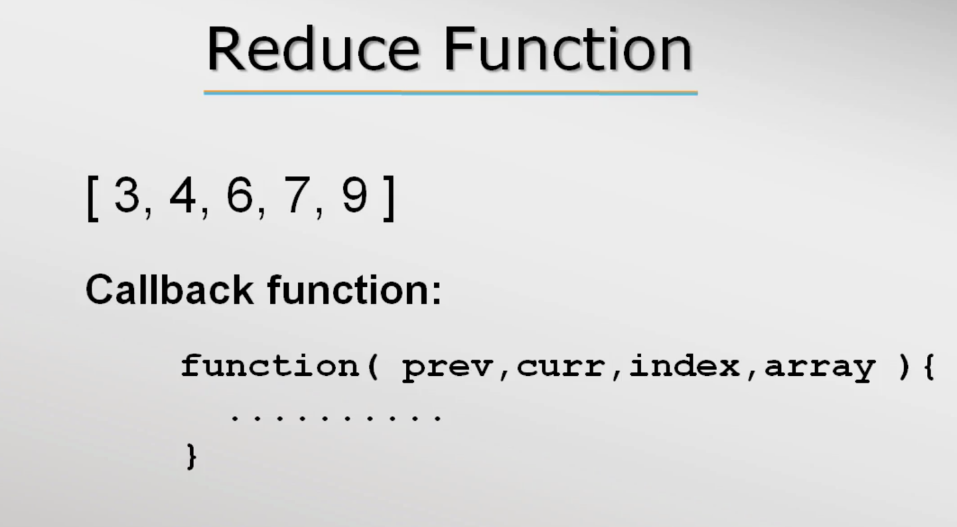

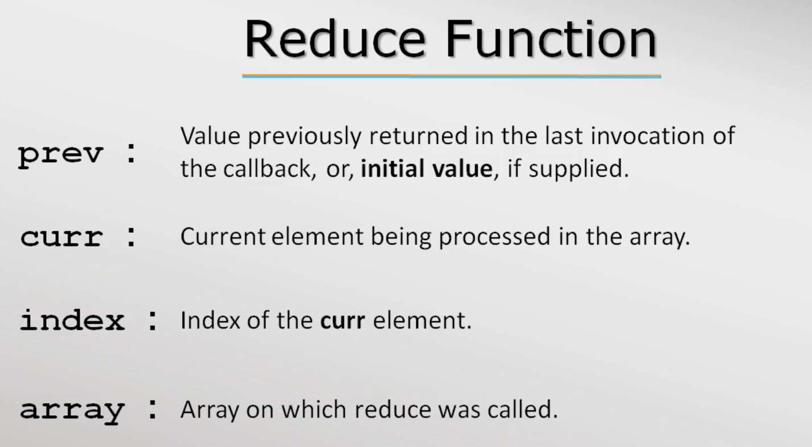

Ex:

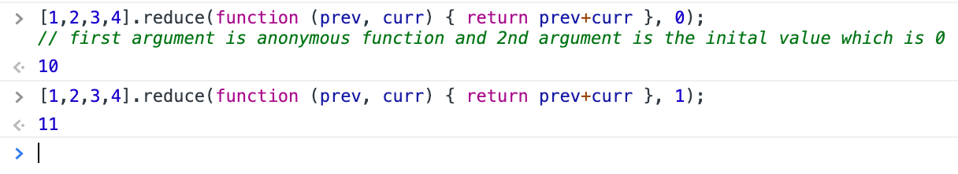

Explanation:

Call 1

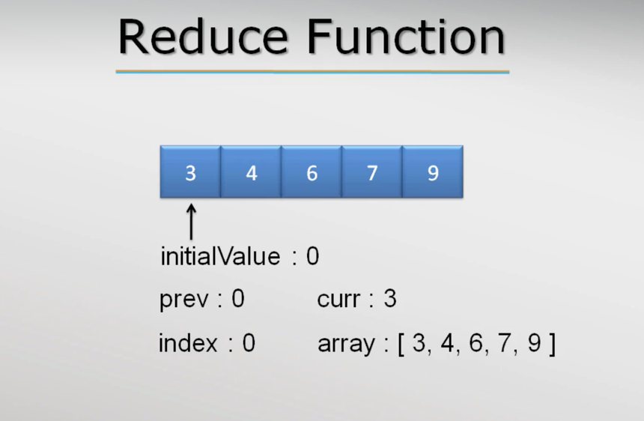

Call 2

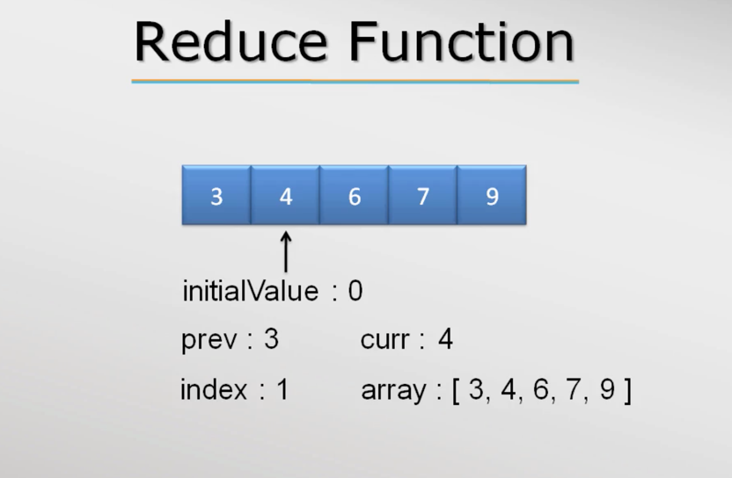

Call goes till it reaches the last ele

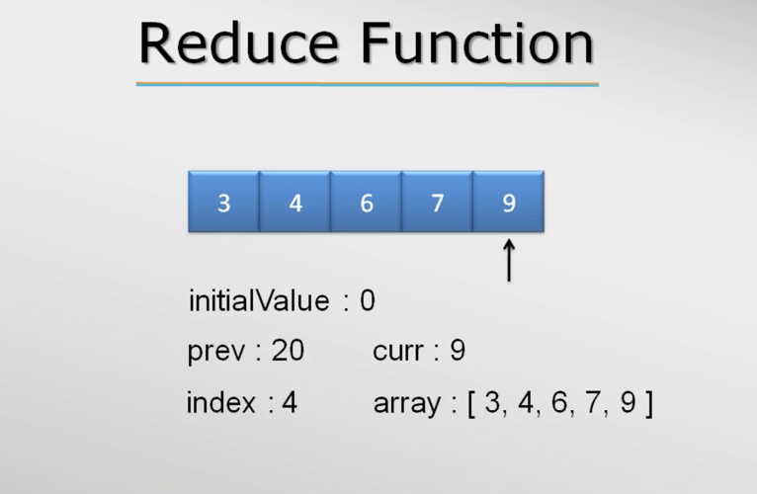

Ex: In the below rest of the arguments were logged

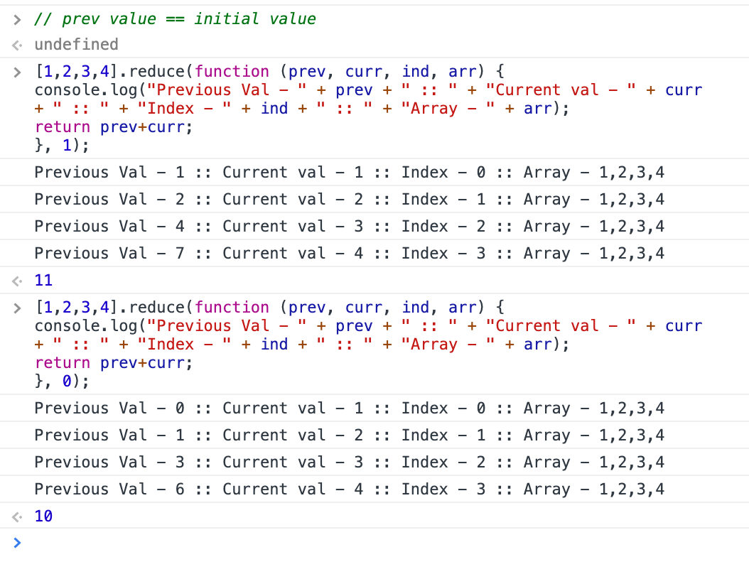

Ex: sum of natural numbers using reduce while the input is number

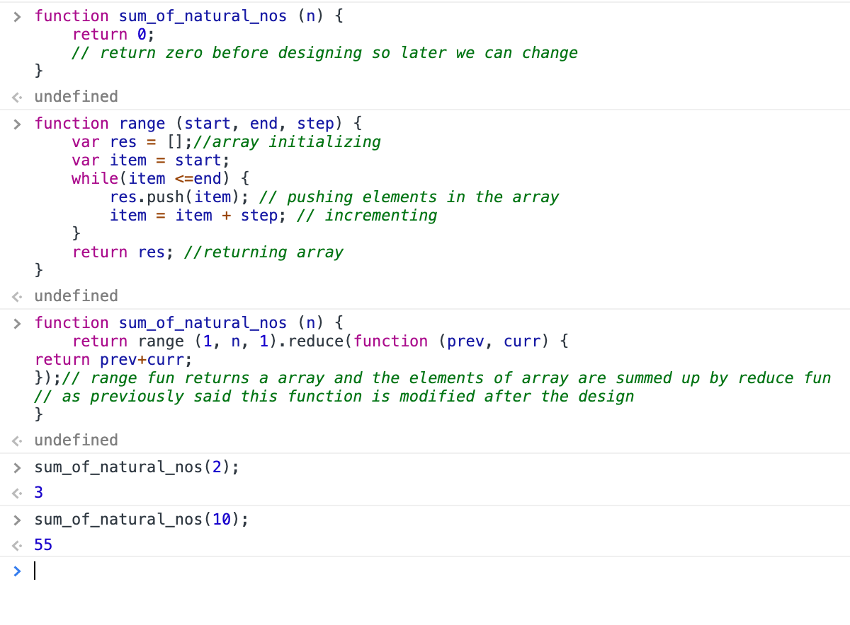

Accessing variable numbers of arguments

- JS has inbuilt arguments object which is array like but not really an array. It will help to get the arguments passed in a functions and list them like array(not exactly array) even if parameters are not defined in the function. But we can’t process the arguments since they aren’t array. The bellow screenshots will give clarity,

Screen shot 1:

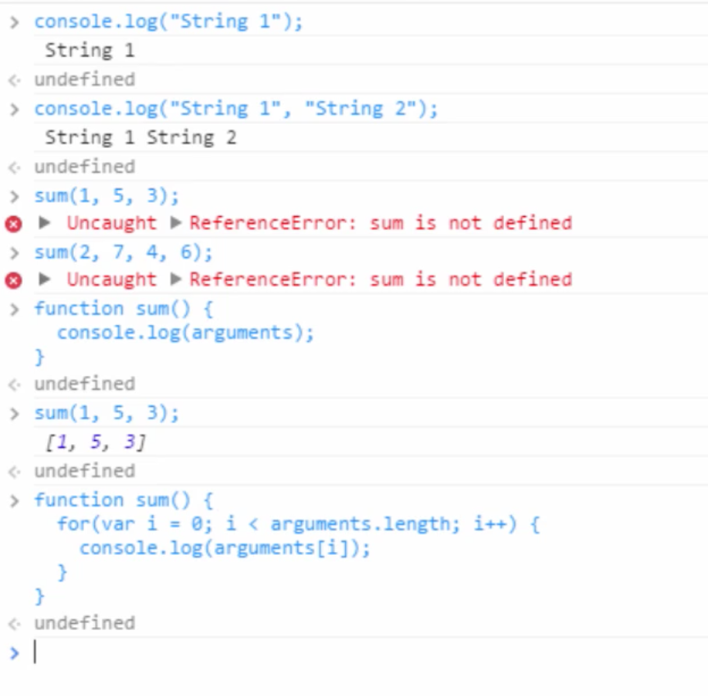

Screenshot2:

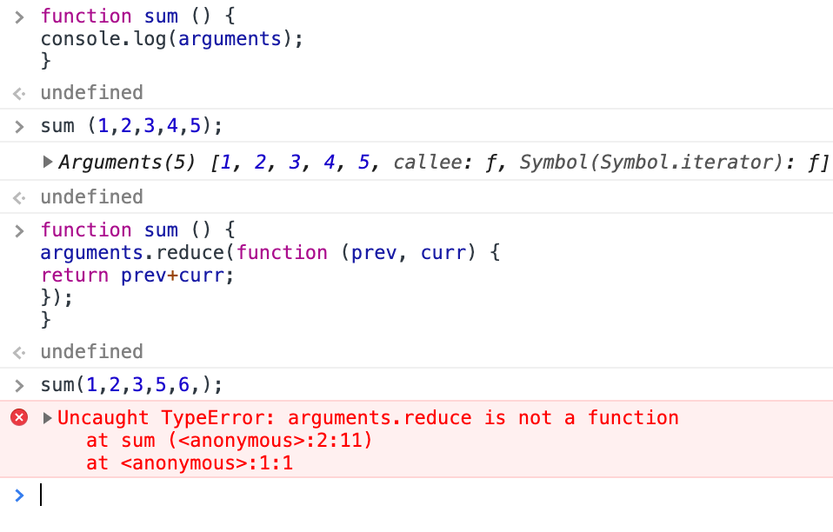

To use the argument as array we need to process it first below some more things we explained so read the comments

